ФОТО С СЕДЬМОГО СЪЕЗДА ЛИДЕРОВ МИРОВЫХ И ТРАДИЦИЦИОННЫХ РЕЛИГИЙ 2022 ГОДА В КАЗАХСТАНЕ Г. АСТАНА
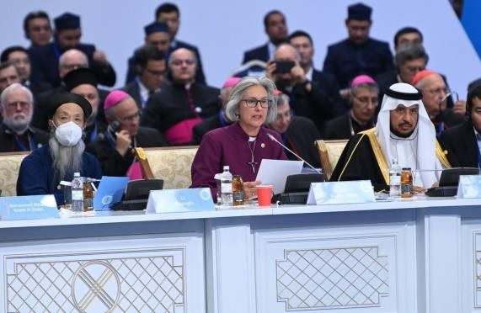

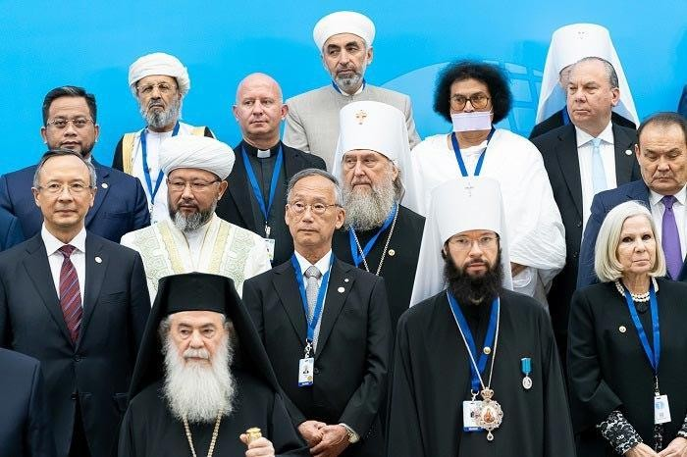
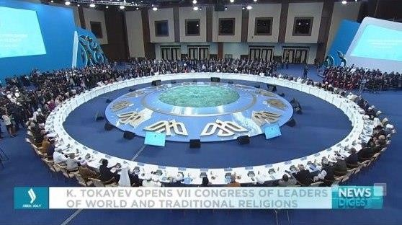
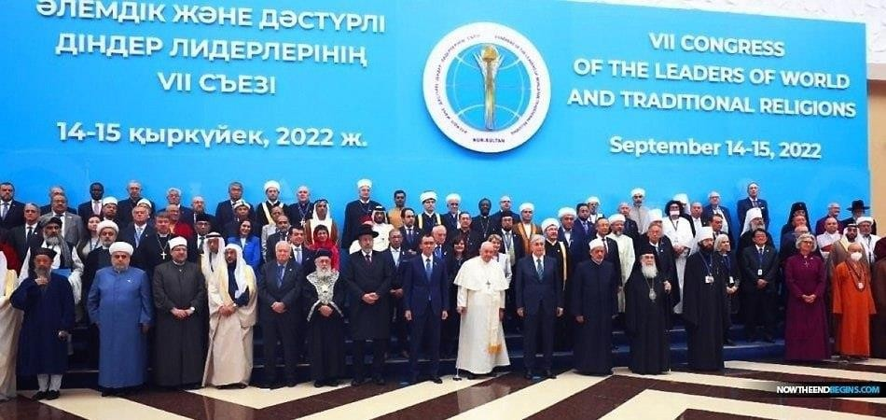

ВИДЕО СЪЕЗДА МИРОВЫХ РЕЛИГИЙ, А ИМЕННО ВЫСТУПЛЕНИЕ ГЛАВНОГО РАВВИНА ИЗРАИЛЯ ДАВИДА ЛАУ, ГДЕ ОН ГОВОРИТ О СОВМЕСТНОЙ МОЛИТ- ВЕ ВСЕХ РЕЛИГИЙ.
Цитата из выступления: «…Мы все дети единого бога, мы все потомки одного челове- ка. Мы влияем на этот мир. И хотел бы поблагодарить президента республики Казахстан, ко- торый собрал нас, этим посланием. Мы вернемся в свои страны, к своим народам, к своим общинами, и хочу еще раз повторить. Мы просим отметить этот важный момент, ту вели- кую молитву, которой мы молимся всем вместе…»
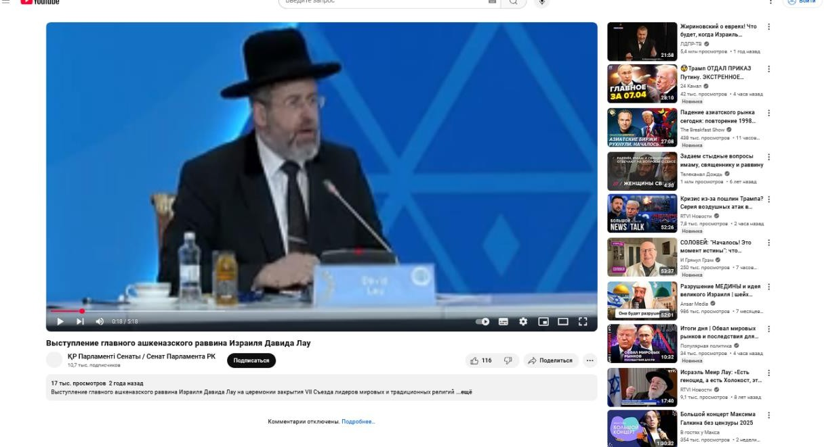
ССЫЛКА НА ВИДЕО С ЮТУБА: https://www.youtube.com/watch?v=P6ISGzQYI8c

СКРИНШОТ НА ВИ- ДЕО С ЮТУБА

ССЫЛКА НА СТАЬЮ ИЗ САЙТА ЮНЕСКО, ЧТО В КАЗАСТАНЕ, Г. АСТАНА ПРОШЕЛ СЕДЬ- МОЙ СЪЕЗД МИРОВЫХ И ТАРДИЦИОННЫХ РЕЛИГИЙ -
https://www.unesco.org/ru/articles/sedmoy-sezd-liderov-mirovykh-i-tradicionnykh-religiy-proshel-v-astane
ПЕРЕХОДЯ ПО ССЫЛКЕ ЗАХОДИМ НА СТАТЬЮ И ИДЕМ ЧУТЬ НИЖЕ, ГДЕ БУДЕТ ПРЕД- СТАВЛЕН ДОКУМЕНТ «ДЕКЛАРАЦИЯ СЕДЬМОГО СЪЕЗДА ЛИДЕРОВМИРОВЫХ И ТРАДИ- ЦИОННЫХ РЕЛИГИЙ 2022 ГОДА». ДОКУМЕНТ ВЫДЕЛЕН КРАСНЫМ
ССЫЛКА НА ДОКУМЕНТ ДЕКЛАРАЦИЮ
https://articles.unesco.org/sites/default/files/medias/fichiers/2023/06/DECLARATION%20OF%20VII%20C ONGRESS.pd

ДОКУМЕНТ БОЛЬШОЙ НА РАЗНЫХ ЯЗЫКАХ. ВЫДЕРЖКА ИЗ РУССКОГО ДОКУМЕН- ТА ДЕКЛАРАЦИИ
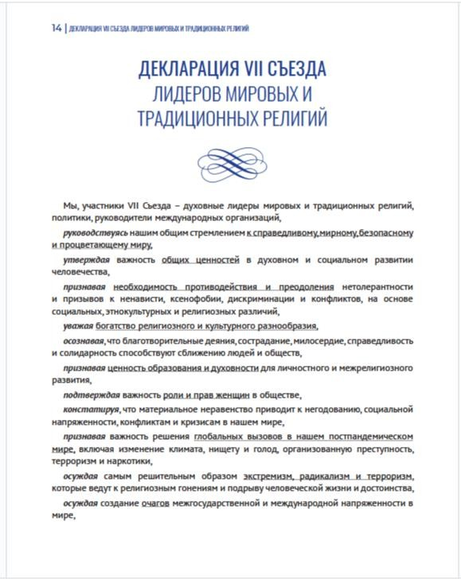

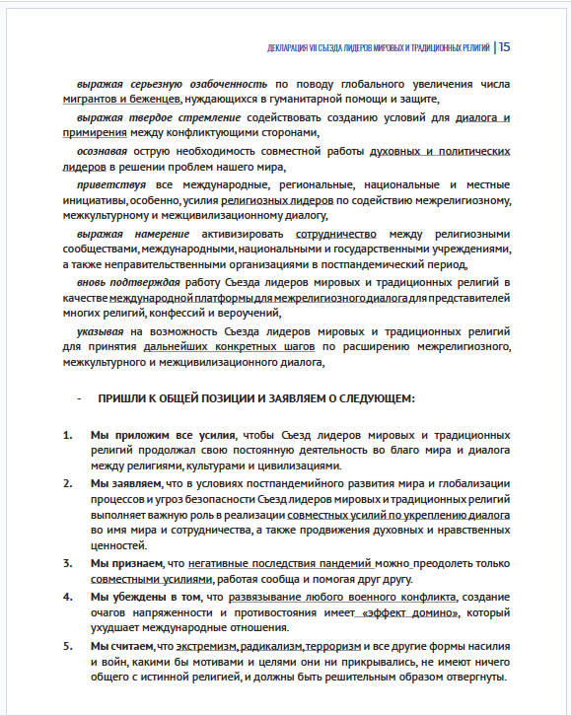

ДОКУМЕНТ ДЕКЛАРАЦИИ В 13 ПУНКТЕ ССЫЛАЕТСЯ НА ДОКУМЕНТ О ЧЕЛОВЕЧЕ- СКОМ БРАТСТВЕ
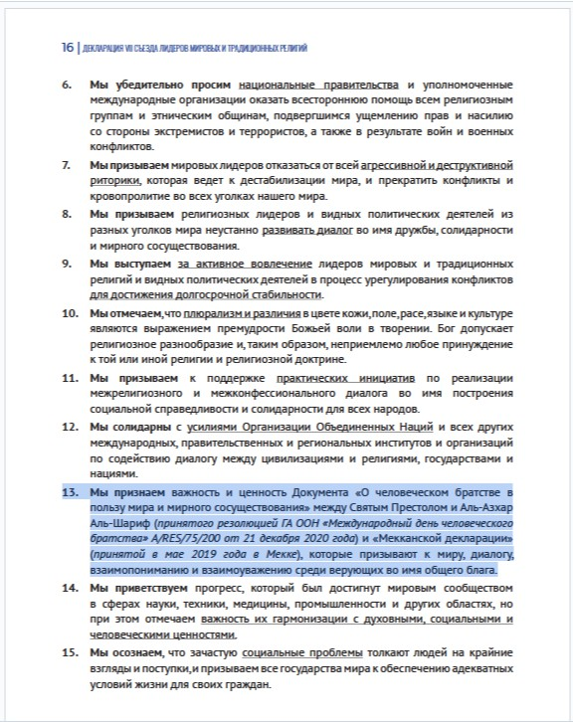

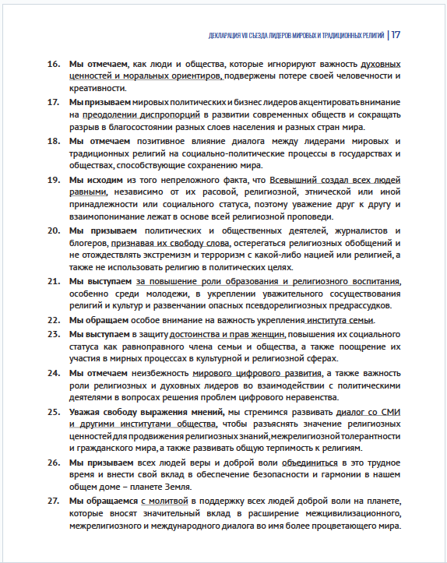

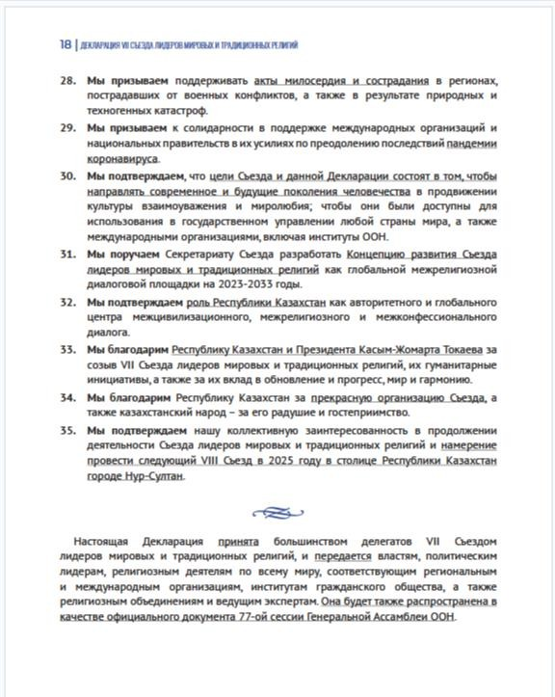

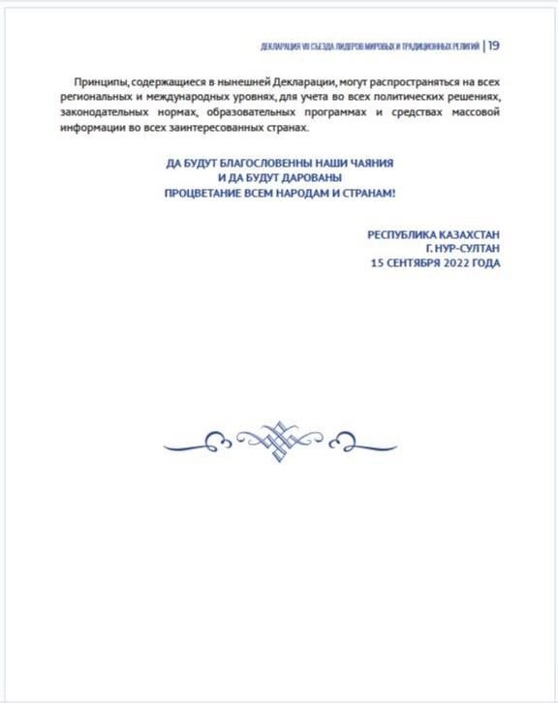

ДОКУМЕНТ О ЧЕЛОВЕЧЕСКОМ БРАТСВЕ ЗА МИР ВО ВСЕМ МИРЕ И СОВМЕСТНУЮ ЖИЗНЬ.
ССЫЛКА НА ДОКУМЕНТ ЧЕЛОВЕЧЕСКОМ БРАТСТВЕ.
https://www.vatican.va/content/francesco/en/travels/2019/outside/documents/papa- francesco_20190204_documento-fratellanza-umana.html
ОФИЦИАЛЬНЫЙ САЙТ ПАПЫ РИМСКОГО, ОТКУДЯ ВЗЯТ ДОКУМЕНТ
https://www.vatican.va

АНГЛИЙСКАЯ ВЕРСИЯ ДОКУМЕНТА

APOSTOLIC JOURNEY OF HIS HOLINESS POPE FRANCIS TO THE UNITED ARAB EMIRATES
(3-5 FEBRUARY 2019)

A DOCUMENT ON HUMAN FRATERNITY
FOR WORLD PEACE AND LIVING TOGETHER
[Multimedia]

INTRODUCTION
Faith leads a believer to see in the other a brother or sister to be supported and loved. Through faith in God, who has created the universe, creatures and all human beings (equal on account of his mercy), believers are called to express this human fraternity by safeguarding creation and the entire universe and supporting all persons, especially the poorest and those most in need.
This transcendental value served as the starting point for several meetings characterized by a friendly and fraternal atmosphere where we shared the joys, sorrows and problems of our contemporary world. We did this by considering scientific and technical progress, therapeutic achievements, the digital era, the mass me- dia and communications. We reflected also on the level of poverty, conflict and suffering of so many broth- ers and sisters in different parts of the world as a consequence of the arms race, social injustice, corruption, inequality, moral decline, terrorism, discrimination, extremism and many other causes.
From our fraternal and open discussions, and from the meeting that expressed profound hope in a bright fu- ture for all human beings, the idea of this Document on Human Fraternity was conceived. It is a text that has been given honest and serious thought so as to be a joint declaration of good and heartfelt aspirations. It is a document that invites all persons who have faith in God and faith in human fraternity to unite and work to- gether so that it may serve as a guide for future generations to advance a culture of mutual respect in the awareness of the great divine grace that makes all human beings brothers and sisters.

DOCUMENT
In the name of God who has created all human beings equal in rights, duties and dignity, and who has called them to live together as brothers and sisters, to fill the earth and make known the values of goodness, love and peace;
In the name of innocent human life that God has forbidden to kill, affirming that whoever kills a person is like one who kills the whole of humanity, and that whoever saves a person is like one who saves the whole of humanity;

In the name of the poor, the destitute, the marginalized and those most in need whom God has commanded us to help as a duty required of all persons, especially the wealthy and of means;
In the name of orphans, widows, refugees and those exiled from their homes and their countries; in the name of all victims of wars, persecution and injustice; in the name of the weak, those who live in fear, prisoners of war and those tortured in any part of the world, without distinction;
In the name of peoples who have lost their security, peace, and the possibility of living together, becoming victims of destruction, calamity and war;
In the name of human fraternity that embraces all human beings, unites them and renders them equal;
In the name of this fraternity torn apart by policies of extremism and division, by systems of unrestrained profit or by hateful ideological tendencies that manipulate the actions and the future of men and women;
In the name of freedom, that God has given to all human beings creating them free and distinguishing them by this gift;
In the name of justice and mercy, the foundations of prosperity and the cornerstone of faith; In the name of all persons of good will present in every part of the world;
In the name of God and of everything stated thus far; Al-Azhar al-Sharif and the Muslims of the East and West, together with the Catholic Church and the Catholics of the East and West, declare the adoption of a culture of dialogue as the path; mutual cooperation as the code of conduct; reciprocal understanding as the method and standard.
We, who believe in God and in the final meeting with Him and His judgment, on the basis of our religious and moral responsibility, and through this Document, call upon ourselves, upon the leaders of the world as well as the architects of international policy and world economy, to work strenuously to spread the culture of tolerance and of living together in peace; to intervene at the earliest opportunity to stop the shedding of in- nocent blood and bring an end to wars, conflicts, environmental decay and the moral and cultural decline that the world is presently experiencing.
We call upon intellectuals, philosophers, religious figures, artists, media professionals and men and women of culture in every part of the world, to rediscover the values of peace, justice, goodness, beauty, human fra- ternity and coexistence in order to confirm the importance of these values as anchors of salvation for all, and to promote them everywhere.
This Declaration, setting out from a profound consideration of our contemporary reality, valuing its success- es and in solidarity with its suffering, disasters and calamities, believes firmly that among the most im- portant causes of the crises of the modern world are a desensitized human conscience, a distancing from re- ligious values and a prevailing individualism accompanied by materialistic philosophies that deify the hu- man person and introduce worldly and material values in place of supreme and transcendental principles.
While recognizing the positive steps taken by our modern civilization in the fields of science, technology, medicine, industry and welfare, especially in developed countries, we wish to emphasize that, associated with such historic advancements, great and valued as they are, there exists both a moral deterioration that influences international action and a weakening of spiritual values and responsibility. All this contributes to a general feeling of frustration, isolation and desperation leading many to fall either into a vortex of atheis- tic, agnostic or religious extremism, or into blind and fanatic extremism, which ultimately encourage forms of dependency and individual or collective self-destruction.
History shows that religious extremism, national extremism and also intolerance have produced in the world, be it in the East or West, what might be referred to as signs of a “third world war being fought piecemeal”.
In several parts of the world and in many tragic circumstances these signs have begun to be painfully appar- ent, as in those situations where the precise number of victims, widows and orphans is unknown. We see, in addition, other regions preparing to become theatres of new conflicts, with outbreaks of tension and a build- up of arms and ammunition, and all this in a global context overshadowed by uncertainty, disillusionment, fear of the future, and controlled by narrow-minded economic interests.
We likewise affirm that major political crises, situations of injustice and lack of equitable distribution of natural resources – which only a rich minority benefit from, to the detriment of the majority of the peoples of the earth – have generated, and continue to generate, vast numbers of poor, infirm and deceased persons.

This leads to catastrophic crises that various countries have fallen victim to despite their natural resources and the resourcefulness of young people which characterize these nations. In the face of such crises that re- sult in the deaths of millions of children – wasted away from poverty and hunger – there is an unacceptable silence on the international level.
It is clear in this context how the family as the fundamental nucleus of society and humanity is essential in bringing children into the world, raising them, educating them, and providing them with solid moral for- mation and domestic security. To attack the institution of the family, to regard it with contempt or to doubt its important role, is one of the most threatening evils of our era.
We affirm also the importance of awakening religious awareness and the need to revive this awareness in the hearts of new generations through sound education and an adherence to moral values and upright reli- gious teachings. In this way we can confront tendencies that are individualistic, selfish, conflicting, and also address radicalism and blind extremism in all its forms and expressions.
The first and most important aim of religions is to believe in God, to honour Him and to invite all men and women to believe that this universe depends on a God who governs it. He is the Creator who has formed us with His divine wisdom and has granted us the gift of life to protect it. It is a gift that no one has the right to take away, threaten or manipulate to suit oneself. Indeed, everyone must safeguard this gift of life from its beginning up to its natural end. We therefore condemn all those practices that are a threat to life such as genocide, acts of terrorism, forced displacement, human organ trafficking, abortion and euthanasia. We likewise condemn the policies that promote these practices.
Moreover, we resolutely declare that religions must never incite war, hateful attitudes, hostility and extrem- ism, nor must they incite violence or the shedding of blood. These tragic realities are the consequence of a deviation from religious teachings. They result from a political manipulation of religions and from interpre- tations made by religious groups who, in the course of history, have taken advantage of the power of reli- gious sentiment in the hearts of men and women in order to make them act in a way that has nothing to do with the truth of religion. This is done for the purpose of achieving objectives that are political, economic, worldly and short-sighted. We thus call upon all concerned to stop using religions to incite hatred, violence, extremism and blind fanaticism, and to refrain from using the name of God to justify acts of murder, exile, terrorism and oppression. We ask this on the basis of our common belief in God who did not create men and women to be killed or to fight one another, nor to be tortured or humiliated in their lives and circumstances. God, the Almighty, has no need to be defended by anyone and does not want His name to be used to terror- ize people.
This Document, in accordance with previous International Documents that have emphasized the importance of the role of religions in the construction of world peace, upholds the following:
- The firm conviction that authentic teachings of religions invite us to remain rooted in the values of peace; to defend the values of mutual understanding, human fraternity and harmonious coexistence; to re-establish wisdom, justice and love; and to reawaken religious awareness among young people so that future genera- tions may be protected from the realm of materialistic thinking and from dangerous policies of unbridled greed and indifference that are based on the law of force and not on the force of law;

- Freedom is a right of every person: each individual enjoys the freedom of belief, thought, expression and action. The pluralism and the diversity of religions, colour, sex, race and language are willed by God in His wisdom, through which He created human beings. This divine wisdom is the source from which the right to freedom of belief and the freedom to be different derives. Therefore, the fact that people are forced to adhere to a certain religion or culture must be rejected, as too the imposition of a cultural way of life that others do not accept;
- Justice based on mercy is the path to follow in order to achieve a dignified life to which every human being has a right;
- Dialogue, understanding and the widespread promotion of a culture of tolerance, acceptance of others and of living together peacefully would contribute significantly to reducing many economic, social, political and environmental problems that weigh so heavily on a large part of humanity;
- Dialogue among believers means coming together in the vast space of spiritual, human and shared social values and, from here, transmitting the highest moral virtues that religions aim for. It also means avoiding unproductive discussions;

- The protection of places of worship – synagogues, churches and mosques – is a duty guaranteed by reli- gions, human values, laws and international agreements. Every attempt to attack places of worship or threat- en them by violent assaults, bombings or destruction, is a deviation from the teachings of religions as well as a clear violation of international law;
- Terrorism is deplorable and threatens the security of people, be they in the East or the West, the North or the South, and disseminates panic, terror and pessimism, but this is not due to religion, even when terrorists instrumentalize it. It is due, rather, to an accumulation of incorrect interpretations of religious texts and to policies linked to hunger, poverty, injustice, oppression and pride. This is why it is so necessary to stop sup- porting terrorist movements fuelled by financing, the provision of weapons and strategy, and by attempts to justify these movements even using the media. All these must be regarded as international crimes that threaten security and world peace. Such terrorism must be condemned in all its forms and expressions;
- The concept of citizenship is based on the equality of rights and duties, under which all enjoy justice. It is therefore crucial to establish in our societies the concept of full citizenship and reject the discriminatory use of the term minorities which engenders feelings of isolation and inferiority. Its misuse paves the way for hostility and discord; it undoes any successes and takes away the religious and civil rights of some citizens who are thus discriminated against;
- Good relations between East and West are indisputably necessary for both. They must not be neglected, so that each can be enriched by the other’s culture through fruitful exchange and dialogue. The West can dis- cover in the East remedies for those spiritual and religious maladies that are caused by a prevailing material- ism. And the East can find in the West many elements that can help free it from weakness, division, conflict and scientific, technical and cultural decline. It is important to pay attention to religious, cultural and histori- cal differences that are a vital component in shaping the character, culture and civilization of the East. It is likewise important to reinforce the bond of fundamental human rights in order to help ensure a dignified life for all the men and women of East and West, avoiding the politics of double standards;
- It is an essential requirement to recognize the right of women to education and employment, and to recog- nize their freedom to exercise their own political rights. Moreover, efforts must be made to free women from historical and social conditioning that runs contrary to the principles of their faith and dignity. It is also nec- essary to protect women from sexual exploitation and from being treated as merchandise or objects of pleas- ure or financial gain. Accordingly, an end must be brought to all those inhuman and vulgar practices that denigrate the dignity of women. Efforts must be made to modify those laws that prevent women from fully enjoying their rights;
- The protection of the fundamental rights of children to grow up in a family environment, to receive nutri- tion, education and support, are duties of the family and society. Such duties must be guaranteed and pro- tected so that they are not overlooked or denied to any child in any part of the world. All those practices that violate the dignity and rights of children must be denounced. It is equally important to be vigilant against the dangers that they are exposed to, particularly in the digital world, and to consider as a crime the trafficking of their innocence and all violations of their youth;
- The protection of the rights of the elderly, the weak, the disabled, and the oppressed is a religious and so- cial obligation that must be guaranteed and defended through strict legislation and the implementation of the relevant international agreements.
To this end, by mutual cooperation, the Catholic Church and Al-Azhar announce and pledge to convey this Document to authorities, influential leaders, persons of religion all over the world, appropriate regional and international organizations, organizations within civil society, religious institutions and leading thinkers.
They further pledge to make known the principles contained in this Declaration at all regional and interna- tional levels, while requesting that these principles be translated into policies, decisions, legislative texts, courses of study and materials to be circulated.
Al-Azhar and the Catholic Church ask that this Document become the object of research and reflection in all schools, universities and institutes of formation, thus helping to educate new generations to bring goodness and peace to others, and to be defenders everywhere of the rights of the oppressed and of the least of our brothers and sisters.
In conclusion, our aspiration is that:
this Declaration may constitute an invitation to reconciliation and fraternity among all believers, indeed among believers and non-believers, and among all people of good will;

this Declaration may be an appeal to every upright conscience that rejects deplorable violence and blind ex- tremism; an appeal to those who cherish the values of tolerance and fraternity that are promoted and encour- aged by religions;
this Declaration may be a witness to the greatness of faith in God that unites divided hearts and elevates the human soul;
this Declaration may be a sign of the closeness between East and West, between North and South, and be- tween all who believe that God has created us to understand one another, cooperate with one another and live as brothers and sisters who love one another.
This is what we hope and seek to achieve with the aim of finding a universal peace that all can enjoy in this life.
Abu Dhabi, 4 February 2019

His Holiness
Pope Francis The Grand Imam of Al-Azhar
Ahmad Al-Tayye

ПЕРЕВОД ДОКУМЕНТА

Апостольское путешествие Его Святейшества Папы Римского Франциска в Объединенные Арабские Эмираты
(3-5 ФЕВРАЛЯ 2019 ГОДА)
ДОКУМЕНТ О
ЧЕЛОВЕЧЕСКОМ БРАТСТВЕ
ЗА МИР ВО ВСЕМ МИРЕ И СОВМЕСТНУЮ ЖИЗНЬ

[Мультимедиа]

Введение
Вера побуждает верующего видеть в другом человеке брата или сестру, которых нужно под- держивать и любить. Благодаря вере в Бога, сотворившего Вселенную, живых существ и всех людей (равных по милости Божьей), верующие призваны выражать это человеческое братство, защищая творение и всю Вселенную и поддерживая всех людей, особенно самых бедных и нуждающихся.
Эта трансцендентная ценность послужила отправной точкой для нескольких встреч, проходив- ших в дружеской и братской атмосфере, где мы делились радостями, печалями и проблемами нашего современного мира. Мы обсуждали научно-технический прогресс, достижения в области медицины, цифровую эпоху, средства массовой информации и коммуникации. Мы также размышляли об уровне бедности, конфликтах и страданиях многих братьев и сестёр в разных частях света, вызванных гон- кой вооружений, социальной несправедливостью, коррупцией, неравенством, моральным упадком, терроризмом, дискриминацией, экстремизмом и многими другими причинами.
В результате наших братских и открытых дискуссий и встречи, на которой была выражена глу- бокая надежда на светлое будущее для всех людей, родилась идея этого Документа о Человеческом братстве. Это текст, который был честно и серьезно обдуман, с тем чтобы стать совместной декла- рацией добрых и искренних устремлений. Это документ, который призывает всех людей, верящих в Бога и в человеческое братство, объединиться и работать вместе, чтобы он мог служить руковод- ством для будущих поколений в продвижении культуры взаимного уважения в осознании великой божественной милости, которая делает всех людей братьями и сёстрами.
ДОКУМЕНТ

Во имя Бога, сотворившего всех людей равными в правах, обязанностях и достоинстве и призвавшего их жить вместе как братья и сёстры, населять землю и распространять ценности добра, любви и мира;
Во имя невинной человеческой жизни, которую Бог запретил убивать, утверждая, что тот, кто убивает человека, подобен тому, кто убивает всё человечество, и что тот, кто спасает человека, подо- бен тому, кто спасает всё человечество;
Во имя бедных, обездоленных, маргинализированных и наиболее нуждающихся, которым Бог повелел нам помогать, как того требует долг каждого человека, особенно состоятельных и обеспе- ченных;

От имени сирот, вдов, беженцев и тех, кто был изгнан из своих домов и стран; от имени всех жертв войн, преследований и несправедливости; от имени слабых, тех, кто живёт в страхе, военно- пленных и тех, кто подвергается пыткам в любой части света, без исключения;
От имени народов, которые лишились безопасности, мира и возможности жить вместе, став жертвами разрушений, бедствий и войн;
Во имя человеческого братства, которое охватывает всех людей, объединяет их и делает рав- ными;
Во имя этого братства, разделённого политикой экстремизма и разобщённости, системами не- ограниченной наживы или ненавистническими идеологическими тенденциями, которые манипули- руют действиями и будущим мужчин и женщин;
Во имя свободы, которую Бог даровал всем людям, сделав их свободными и выделив их этим даром;
Во имя справедливости и милосердия, основ процветания и краеугольного камня веры; От имени всех людей доброй воли, живущих в любой точке мира;
Во имя Бога и всего, о чём говорилось до сих пор, Аль-Азхар аль-Шариф и мусульмане Востока и Запада вместе с Католической церковью и католиками Востока и Запада провозглашают культуру диалога в качестве пути, взаимное сотрудничество в качестве кодекса поведения, взаимное понима- ние в качестве метода и стандарта.
Мы, верующие в Бога и в окончательную встречу с Ним и Его суд, исходя из нашей религиоз- ной и нравственной ответственности, призываем себя, лидеров мира, а также архитекторов междуна- родной политики и мировой экономики приложить все усилия для распространения культуры тер- пимости и совместного мирного проживания; вмешаться при первой же возможности, чтобы остано- вить пролитие невинной крови и положить конец войнам, конфликтам, ухудшению состояния окру- жающей среды и моральному и культурному упадку, которые переживает мир в настоящее время.
Мы призываем интеллектуалов, философов, религиозных деятелей, художников, представите- лей СМИ, а также мужчин и женщин, занимающихся культурой, во всех уголках мира заново от- крыть для себя ценности мира, справедливости, добра, красоты, человеческого братства и сосуще- ствования, чтобы подтвердить важность этих ценностей как основы спасения для всех и продвигать их повсеместно.
Эта Декларация, основанная на глубоком анализе нашей современной реальности, признающая её успехи и солидарная с её страданиями, катастрофами и бедствиями, твёрдо убеждена, что среди важнейших причин кризисов современного мира — бесчувственность человеческой совести, отход от религиозных ценностей и преобладающий индивидуализм, сопровождающийся материалистиче- скими философиями, которые обожествляют человека и ставят мирские и материальные ценности выше высших и трансцендентных принципов.
Признавая положительные шаги, предпринятые нашей современной цивилизацией в области науки, технологий, медицины, промышленности и социального обеспечения, особенно в развитых странах, мы хотим подчеркнуть, что наряду с такими историческими достижениями, какими бы зна- чительными и ценными они ни были, существует моральное разложение, влияющее на международ- ные действия, а также ослабление духовных ценностей и ответственности. Всё это способствует воз- никновению общего чувства разочарования, изоляции и отчаяния, из-за чего многие впадают либо в пучину атеистического, агностического или религиозного экстремизма, либо в слепой и фанатичный экстремизм, которые в конечном счёте поощряют формы зависимости и индивидуальное или коллек- тивное самоуничтожение.
История показывает, что религиозный экстремизм, национальный экстремизм, а также нетер- пимость привели к тому, что в мире, будь то на Востоке или на Западе, появились признаки «третьей мировой войны, которая ведётся по частям». В некоторых частях света и при многих трагических об- стоятельствах эти признаки стали болезненно очевидными, как в тех ситуациях, когда точное число жертв, вдов и сирот неизвестно. Кроме того, мы видим, что другие регионы готовятся стать ареной новых конфликтов, где вспыхивают напряжённые ситуации и накапливаются вооружения и боепри- пасы, и всё это происходит в глобальном контексте, омрачённом неопределённостью, разочаровани- ем, страхом перед будущим и контролируемом узкими экономическими интересами.
Мы также утверждаем, что крупные политические кризисы, ситуации несправедливости и не- равномерного распределения природных ресурсов, от которых извлекает выгоду лишь богатое меньшинство в ущерб большинству народов Земли, привели и продолжают приводить к появлению огромного числа бедных, немощных и умерших людей. Это приводит к катастрофическим кризисам, жертвами которых становятся различные страны, несмотря на их природные ресурсы и находчивость молодёжи, характерную для этих стран. Перед лицом таких кризисов, которые приводят к гибели миллионов детей, умирающих от нищеты и голода, на международном уровне царит недопустимое молчание.
В этом контексте становится ясно, что семья как основополагающее ядро общества и человече- ства играет важнейшую роль в появлении детей на свет, их воспитании, обучении и обеспечении им прочного нравственного воспитания и внутренней безопасности. Нападки на институт семьи, пре- зрительное отношение к нему или сомнение в его важной роли — одно из самых опасных зол нашего времени.
Мы также утверждаем важность пробуждения религиозного сознания и необходимость возро- дить это сознание в сердцах новых поколений с помощью качественного образования и привержен- ности нравственным ценностям и праведным религиозным учениям. Таким образом мы можем про-

тивостоять индивидуалистическим, эгоистичным, противоречивым тенденциям, а также радикализ- му и слепому экстремизму во всех его формах и проявлениях.
Первая и самая важная цель религий — верить в Бога, почитать Его и призывать всех мужчин и женщин верить в то, что эта Вселенная зависит от Бога, который ею управляет. Он — Творец, кото- рый создал нас Своей божественной мудростью и даровал нам дар жизни, чтобы мы защищали его. Это дар, который никто не имеет права отнимать, угрожать им или манипулировать им в своих инте- ресах. Действительно, каждый должен беречь этот дар жизни с момента его появления и до есте- ственного конца. Поэтому мы осуждаем все действия, угрожающие жизни, такие как геноцид, терро- ристические акты, насильственное перемещение, торговля человеческими органами, аборты и эвта- назия. Мы также осуждаем политику, которая поощряет эти действия.
Более того, мы решительно заявляем, что религии никогда не должны подстрекать к войне, ненависти, вражде и экстремизму, а также к насилию и кровопролитию. Эти трагические реалии яв- ляются следствием отхода от религиозных учений. Они возникают в результате политических мани- пуляций с религиями и интерпретаций, сделанных религиозными группами, которые на протяжении истории использовали силу религиозных чувств в сердцах мужчин и женщин, чтобы заставить их действовать вопреки истине религии. Это делается для достижения политических, экономических, мирских и недальновидных целей. Поэтому мы призываем всех заинтересованных лиц прекратить использовать религию для разжигания ненависти, насилия, экстремизма и слепого фанатизма, а так- же воздерживаться от использования имени Бога для оправдания убийств, изгнаний, терроризма и угнетения. Мы просим об этом, исходя из нашей общей веры в Бога, который не создавал мужчин и женщин для того, чтобы их убивали или заставляли воевать друг с другом, а также для того, чтобы их пытали или унижали в их жизни и обстоятельствах. Бог Всемогущий не нуждается ни в чьей за- щите и не хочет, чтобы Его имя использовалось для устрашения людей.
Настоящий документ в соответствии с предыдущими международными документами, в кото- рых подчёркивалась важность роли религий в построении мира во всём мире, подтверждает следу- ющее:
- твёрдая убеждённость в том, что истинные учения религий призывают нас придерживаться ценностей мира; защищать ценности взаимопонимания, человеческого братства и гармоничного со- существования; возрождать мудрость, справедливость и любовь; пробуждать религиозную созна- тельность у молодёжи, чтобы защитить будущие поколения от царства материалистического мышле- ния и опасной политики необузданной жадности и безразличия, основанных на законе силы, а не на силе закона;
- Свобода — это право каждого человека: каждый человек обладает свободой вероисповеда- ния, мысли, самовыражения и действий. Плюрализм и разнообразие религий, цвета кожи, пола, расы и языка были задуманы Богом в Его мудрости, с помощью которой Он создал людей. Эта боже- ственная мудрость является источником права на свободу вероисповедания и свободу быть другим. Поэтому необходимо отвергнуть тот факт, что людей заставляют придерживаться определённой ре- лигии или культуры, а также навязывание культурного образа жизни, который не принимают другие;
- Справедливость, основанная на милосердии, — это путь, по которому нужно идти, чтобы достичь достойной жизни, на которую имеет право каждый человек;
- Диалог, взаимопонимание и повсеместное распространение культуры терпимости, принятия других и мирного сосуществования значительно способствовали бы решению многих экономиче- ских, социальных, политических и экологических проблем, которые так сильно тяготят большую часть человечества;
- Диалог между верующими означает объединение в обширном пространстве духовных, чело- веческих и общих социальных ценностей и, таким образом, передачу высших нравственных добро- детелей, к которым стремятся религии. Это также означает отказ от непродуктивных дискуссий;
- Защита мест поклонения — синагог, церквей и мечетей — является обязанностью, га- рантированной религиями, человеческими ценностями, законами и международными согла- шениями. Любая попытка атаковать места поклонения или угрожать им насильственными нападе- ниями, взрывами или разрушением является отклонением от учений религий, а также явным нару- шением международного права;
- Терроризм вызывает отвращение и угрожает безопасности людей, будь то на Востоке или на Западе, на Севере или на Юге, и сеет панику, ужас и пессимизм, но это не связано с религией, даже когда террористы используют её в своих целях. Скорее, это связано с накоплением неверных толко- ваний религиозных текстов и политикой, связанной с голодом, бедностью, несправедливостью, угне- тением и гордыней. Вот почему так важно прекратить поддерживать террористические движения, подпитываемые финансированием, поставками оружия и стратегиями, а также попытками оправдать эти движения даже с помощью СМИ. Всё это должно рассматриваться как международные преступ- ления, угрожающие безопасности и миру во всём мире. Такой терроризм должен быть осуждён во всех его формах и проявлениях;
- Концепция гражданства основана на равенстве прав и обязанностей, в соответствии с кото- рой все пользуются справедливостью. Поэтому крайне важно внедрить в наших обществах концеп- цию полноценного гражданства и отказаться от дискриминационного использования термина
«меньшинства», который порождает чувство изоляции и неполноценности. Его неправильное ис- пользование прокладывает путь к вражде и раздорам; оно сводит на нет все успехи и лишает некото- рых граждан религиозных и гражданских прав, подвергая их дискриминации.
- Хорошие отношения между Востоком и Западом, бесспорно, необходимы обоим. Ими нель- зя пренебрегать, чтобы каждый мог обогатиться культурой другого посредством плодотворного об-

мена и диалога. Запад может найти на Востоке средства от тех духовных и религиозных недугов, ко- торые вызваны преобладающим материализмом. А Восток может найти на Западе множество эле- ментов, которые помогут ему избавиться от слабости, разобщённости, конфликтов и научного, тех- нического и культурного упадка. Важно обращать внимание на религиозные, культурные и истори- ческие различия, которые являются жизненно важным компонентом формирования характера, куль- туры и цивилизации Востока. Также важно укреплять связь между основными правами человека, чтобы обеспечить достойную жизнь всем мужчинам и женщинам Востока и Запада, избегая полити- ки двойных стандартов.
- Крайне важно признать право женщин на образование и трудоустройство, а также их свобо- ду пользоваться своими политическими правами. Более того, необходимо приложить усилия, чтобы освободить женщин от исторических и социальных ограничений, противоречащих принципам их ве- ры и достоинства. Также необходимо защитить женщин от сексуальной эксплуатации и обращения с ними как с товаром или объектами для получения удовольствия или финансовой выгоды. Соответ- ственно, необходимо положить конец всем этим бесчеловечным и вульгарным практикам, унижаю- щим достоинство женщин. Необходимо внести изменения в те законы, которые мешают женщинам в полной мере пользоваться своими правами;
- Защита основных прав детей на воспитание в семье, на получение питания, образования и поддержки — это обязанность семьи и общества. Такие обязанности должны быть гарантированы и защищены, чтобы ни один ребёнок в любой точке мира не остался без внимания и поддержки. Необ- ходимо осуждать все действия, нарушающие достоинство и права детей. Не менее важно быть бди- тельными в отношении опасностей, которым они подвергаются, особенно в цифровом мире, и счи- тать преступлением торговлю их невинностью и все нарушения прав несовершеннолетних;
- Защита прав пожилых людей, слабых, инвалидов и угнетённых — это религиозная и соци- альная обязанность, которая должна быть гарантирована и защищена строгим законодательством и выполнением соответствующих международных соглашений.
С этой целью, посредством взаимного сотрудничества, Католическая церковь и Аль-Азхар объ- являют и обязуются передать этот Документ властям, влиятельным лидерам, религиозным деятелям всего мира, соответствующим региональным и международным организациям, организациям граж- данского общества, религиозным институтам и ведущим мыслителям. Они также обязуются распро- странять принципы, содержащиеся в настоящей Декларации, на всех региональных и международ- ных уровнях, требуя при этом, чтобы эти принципы были воплощены в политике, решениях, законо- дательных текстах, учебных курсах и материалах для распространения.
Аль-Азхар и Католическая церковь просят, чтобы этот документ стал предметом изучения и размышлений во всех школах, университетах и учебных заведениях, тем самым помогая воспиты- вать новые поколения, чтобы они несли добро и мир другим и повсюду защищали права угнетённых и самых бедных из наших братьев и сестёр.
В заключение, наше стремление заключается в том, чтобы:
эта Декларация может стать призывом к примирению и братству между всеми верующими, а также между верующими и неверующими и между всеми людьми доброй воли;
Эта Декларация может стать призывом к каждой чистой совести, отвергающей прискорбное насилие и слепой экстремизм; призывом к тем, кто дорожит ценностями терпимости и братства, ко- торые продвигаются и поощряются религиями;
эта Декларация может стать свидетельством величия веры в Бога, которая объединяет разде- лённые сердца и возвышает человеческую душу;
Эта Декларация может стать символом близости между Востоком и Западом, между Севером и Югом, а также между всеми, кто верит, что Бог создал нас, чтобы мы понимали друг друга, сотруд- ничали друг с другом и жили как братья и сёстры, любящие друг друга.
Это то, чего мы надеемся и стремимся достичь, чтобы обрести всеобщий мир, которым все смогут наслаждаться в этой жизни.
Абу-Даби, 4 февраля 2019 года

Его Святейшество  Папа Франциск | Великий имам Аль-Азхара  Ахмад Аль-Тайеб

Представители Русской Православной Церкви приняли участие во Всемирной конференции «Человеческое братство»
ССЫЛКУ НА СТАТЬЮ НА ОФИЦИАЛЬНЫЙ САЙТ ПАТРИАРХИИ - https://patriarchia.ru/article/99879
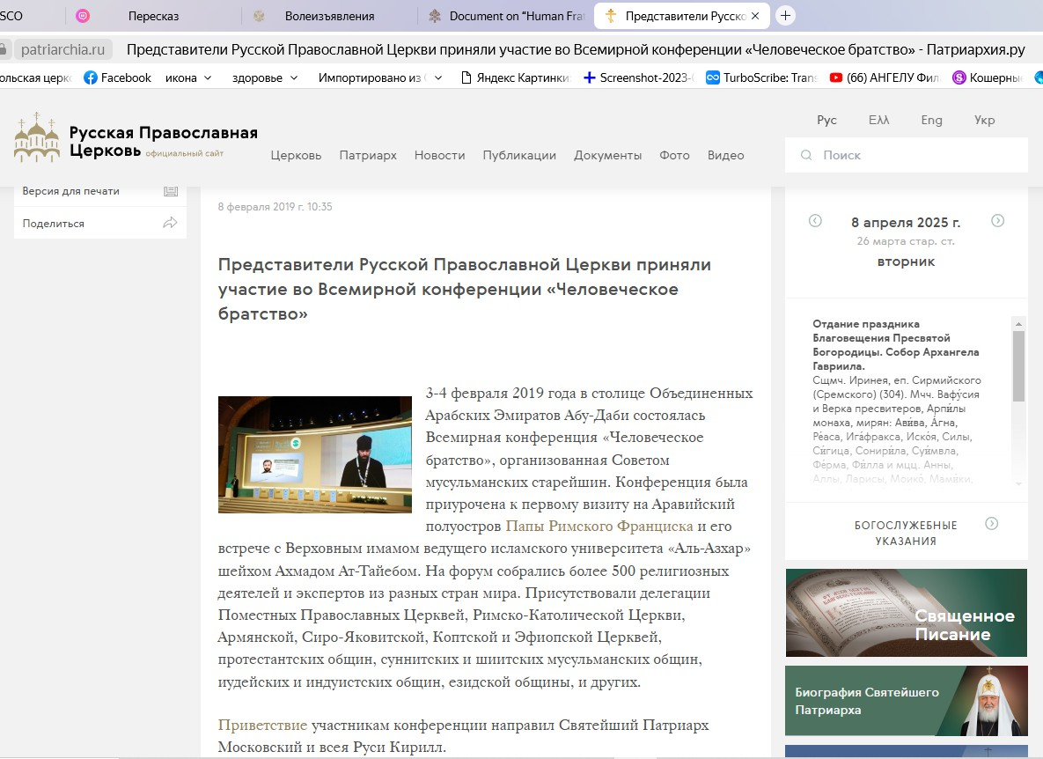
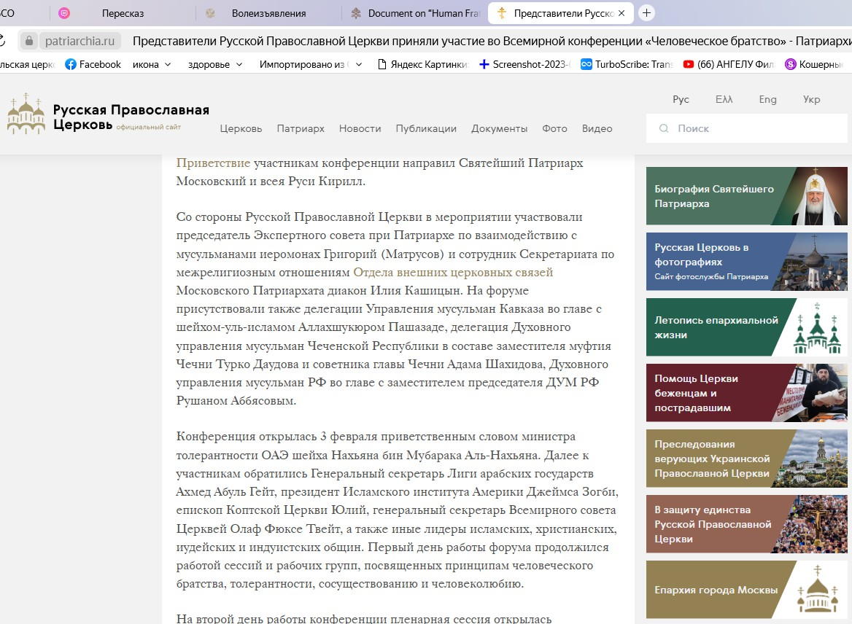

Ссылка на приветствие патриарха Кирилла участникам Всемирной конференции на тему человеческого братства на сайте патриархии - https://patriarchia.ru/article/99879
